# Standard operating procedure for the XCT toolchain software suite

Louis Verschuren, Vladimir Maskovsky, Tom De Mil, Jan Van den Bulcke

## Introduction

Tree rings provide essential insights into historical climate conditions and current ecosystem dynamics. Density measurements complement traditional tree-ring width series by extracting additional climate signals embedded within tree rings, with maximum latewood density serving as the gold standard for summer temperature reconstructions. However, the labor-intensive wood sample preparation required by conventional techniques is limiting the widespread use of tree-ring densitometry. X-ray micro-CT (XµCT) offers a novel, non-destructive, 3D densitometry technique that enables simultaneous study of tree ring width and wood density at high resolution and with minimal sample preparation.

Over the course of 10+ years, UGent-Woodlab has developed a highly optimized XµCT pipeline aimed at large-scale tree-ring densitometry studies, capable of processing large amounts of increment cores while having a low demand for human labor time and active scanner time. This pipeline includes free software packages to process scans and measure the digital increment cores. Overall, this XµCT toolchain represents a significant leap forward in tree-ring densitometry, enabling large-scale studies with a wide spatial extent, high replication, or long temporal range.

The in-house developed XCT Toolchain software suite, based on MATLAB, consists of three executable programs: CoreProcessor, which extracts individual cores from scans and converts them to absolute density values; RingIndicator, designed for semi-automatic ring indication and density profile calculation; and CoreComparison, which facilitates cross-dating. The packages are compiled for Microsoft Windows and require the free installation of MATLAB Runtime (R2024b).

## More info and how to cite

For downloads, **video manuals**, more general info, and info on how to cite this toolchain: please visit <https://dendrochronomics.ugent.be/>

## License and warranty disclaimer

This software is protected under the GNU AGPLv3 license.

The software is distributed without any warranty, without even the implied warranty of MERCHANTABILITY or FITNESS FOR A PARTICULAR PURPOSE. It cannot be used for commercial purposes. Always check the results in a software package such as ImageJ.

## Preparing your samples

* **Paper Straws**: The increment cores are stored in 6 mm paper straws (Artstraws®). Wrap both ends tightly and cut them for easy insertion into the cylindrical holder. Indicate the cambium (bark) side clearly and indicate the sample name. Broken samples should be taped together with paper tape. Make sure the fiber orientation is consistent between broken parts. Also, make sure that the broken sections do not overlap.
* **Soxhlet**: Conifer MXD studies require a water and ethanol Soxhlet extraction to remove resins.
* **Oven dry: before scanning, the samples are dried in an oven for 24h at 103°C. The samples are then cooled down in an air-tight container with ample amounts of silica gel.**



## Scanning the samples

1. **Mounting samples**: The samples are inserted in 3D-printed holders. The samples are always oriented with the bark side down.
2. **Excel file**: While mounting the samples, fill in the metadata in the Excel file.
3. **CT-scanning: The table below shows an overview of the settings used when using a TESCAN CoreTOM:**
4. **Heel correction and reconstruction:** Due to the helical scan trajectory, the projections should be corrected for the heel effect before reconstruction.

|  |  |  |  |  |
| --- | --- | --- | --- | --- |
|  | **High res. fast** | **High res. optimal** | **Medium res.** | **Low res.** |
| **Voxel size (µm)** | 15 | 15 | 30 | 60 |
| **Smooth or step-and-shoot scan** | smooth | step-and-shoot | smooth | smooth |
| **Exposure time per projection (ms)** | 180 | 1400 | 360 | 180 |
| **Power (W)** | 15 | 15 | 30 | 60 |
| **Voltage (kV)** | 100 | 100 | 100 | 100 |
| **SDD (mm)** | 600 | 600 | 600 | 600 |
| **SOD (mm)** | 60 | 60 | 120 | 120 |
| **Projections per turn** | 4075 | 4075 | 4075 | 2037 |
| **Detector binning mode** | 1 | 1 | 1 | 2 |
| **Aluminum filter thickness (mm alu)** | 0.5 | 0.5 | 0.5 | 0.5 |
| **Samples per scan** | 16 | 16 | 52 | 52 |
| **Holder length (cm)** | 35 | 35 | 60 | 60 |
| **Scantime full holder (min.)** | 82 | 1440 | 140 | 34 |
| **Scantime per 35 cm sample (min.)** | 5.13 | 90.00 | 1.57 | 0.38 |

**Software packages**

**Introduction**

The in-house developed XCT Toolchain software suite, based on MATLAB, consists of three executable programs: CoreProcessor, which extracts individual cores from scans and converts them to absolute density values; RingIndicator, designed for semi-automatic ring indication and density profile calculation; and CoreComparison, which facilitates cross-dating. The packages are compiled for Microsoft Windows, and require the free installation of MATLAB Runtime.

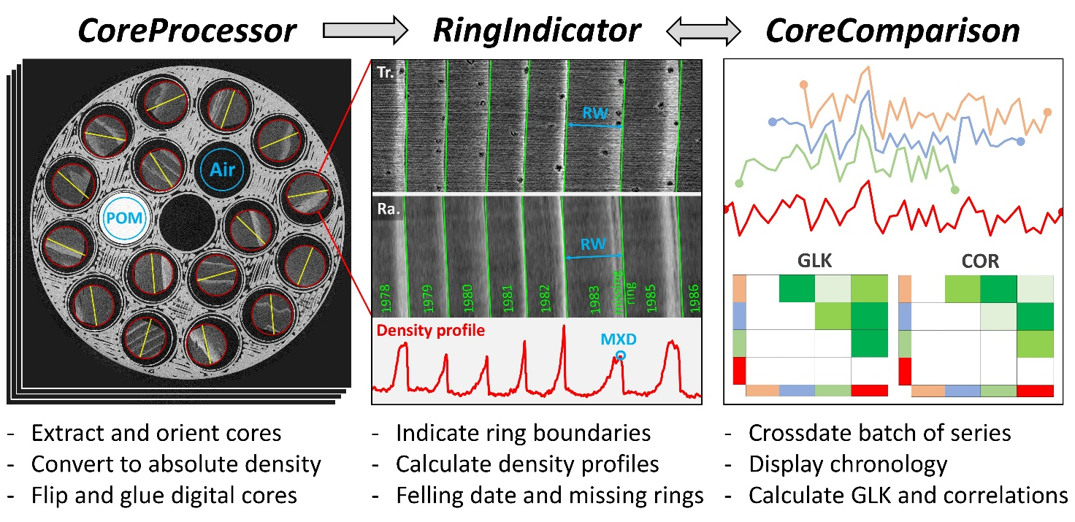

**Getting Started**

1. Go to <https://dendrochronomics.ugent.be> to download the software packages.
2. Download and install MATLAB runtime (check for the correct version).
3. Run the .exe files.

**CoreProcessor**

CoreProcessor is the first program in the XCT toolchian. It extracts image volumes of individual samples from scans, orients them according to the vertical fiber direction, and converts them to absolute density values.

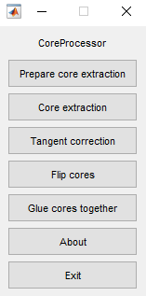

**Prepare core extraction**

1. Indicate the folder with the reconstructed scan files.
2. Indicate the correct Excel file with metadata.
3. Indicate the folder where to put the .mat files. Make this a central location where you will put all the mat files for extraction.
4. Select an air reference by clicking and dragging to create a circular selection, double-click to confirm the selection. Ensure the selection contains only air and is away from the edges. If you have multiple, indicate them in the correct order of each group.
5. Repeat this process for the POM reference.
6. Choose either smooth or linear interpolation for the reference profile. Raw values are not recommended.
7. Select the samples in the correct order as listed in the Excel file. Double-click to confirm each selection.
8. Indicate the fiber direction by clicking and dragging a line along the central slice.
9. Crop the volume to remove unnecessary air. Ensure the center of the crop is aligned with the center of the core.
10. Repeat this whole process for all scans before starting the extraction process.

**Core extraction**

1. Select the folder containing the .mat files.
2. The software will automatically extract the cores and save them inside the scan folders.
3. Each core will have three files: the main core file, a radial preview file, and a transverse preview file.

**Tangent correction**

1. If the tangent correction is not to your liking with some cores, create a new folder and put all of them in that folder. Make sure to remove the radial and transverse preview files.
2. Select the folder with cores to redo the tangent correction.
3. Indicate the fiber direction by clicking and dragging a line along the central slice.
4. Crop the volume to remove unnecessary air. Ensure the center of the crop is aligned with the center of the core.

**Flip cores**

1. If some of the cores were not oriented correctly in the scan holder, the bark would be on the left side. This should be on the right, so they have to be flipped.
2. Create a new folder and put all the wrong cores in that. Make sure to remove the radial and transverse preview files.
3. Select the folder with cores to flip
4. The cores will be flipped and rewritten to the same folder.

**Glue cores together**

1. This functionality is used to combine multiple core segments into a single file. For example, if the core was too long to fit into the holder.
2. Indicate the core that should be on the left, so the older part of the core.
3. Indicate the core that should be on the right, so the younger part of the core (with the bark).
4. Indicate what name this glued core should have
5. The glued core is written to the folder with the two parts.
6. Repeat this process if a core exists of more than two parts.

**Editing in ImageJ**

1. If more complex editing of a core is needed, this is possible with Fiji ImageJ.
2. Make sure to remove the radial and transverse preview files before editing.
3. Open the extracted core files in ImageJ for editing, like reslicing, cropping, or straightening.
4. Save the edited files, and they will be compatible with the Ring Indicator software, retaining all necessary metadata.

**RingIndicator**

RingIndicator is the second program in the XCT toolchain. It is designed for semi-automatic ring indication and density profile calculation.

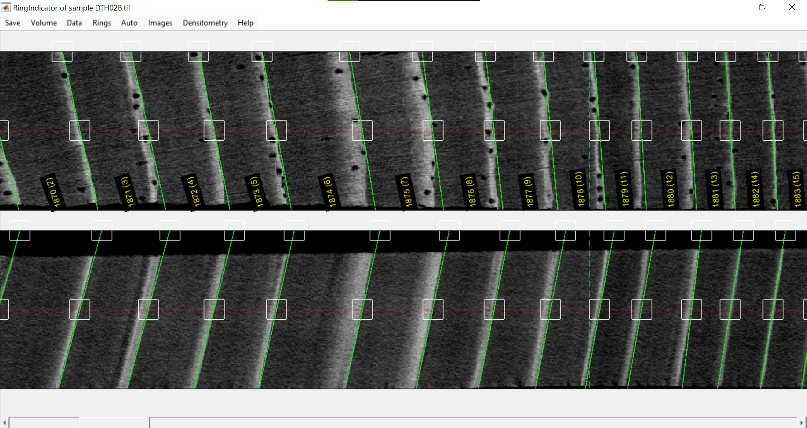

**Running the software**

1. Start the Ring Indicator software.
2. Select the multipage TIFF file you want to open.
3. The software will load the file and display both transverse and radial previews of the 3D core. If any indication were done already, they will be automatically displayed.
4. Indications are saved as .txt files in the same folder as the core, always keep the core and indication together in the same folder.
5. It is possible to have multiple instances of RingIndicator open at the same time.

**Basic functionality**

* **Zoom**: Hold Ctrl and scroll with the mouse.
* **Move**: Use the scroll wheel or use the slider at the bottom.
* **Add a ring**: Click on the desired ring border location.
* **Remove a ring**: Right-click on the middle box.
* **Move a ring**: drag the middle box to move the ring.
* **Change angle**: drag the top box to adjust the ring border angle.
* **Save**: Save your work frequently by using Ctrl S or clicking the save button on the top left.
* **Load a new core**: click volume-> load new volume to load a new core.

**Images: advanced viewing options**

* **Hide Overlays**: Press R to get a clear view without any overlays.
* **Change Views**: Use Ctrl 1, Ctrl 2, and Ctrl 3 to switch between different plane views.
* **Images -> Change grayscale range**: Modify the grayscale range to enhance contrast.
* **Images -> Set slice averaging**: Average a certain number of slices in the Z direction.
* **Images -> Set the transverse/radial plane**:Set the depth at which the slices are displayed. Only exploratory, never use this when indicating rings, stay in the center for that!
* **Images -> Median filter Tv/Ra**: Calculate a median slice to be displayed accounting for the angle of indicated rings. This is very useful for noisy scans and very narrow rings. Indicate a few rings on the radial plane before calculating a median for the radial plane.

**Rings: assign years and handle special cases**

* **Rings -> Set fell date**: Specify what calendar year the last ring is.
* **Rings -> Add missing ring**: Specify the calendar year of a missing ring. Indicate what section of the indications should move their assigned calendar years. Missing rings are assigned to calendar years and stay with that year when changing the surrounding indications.
* **Rings -> Remove missing ring**: Indicate which missing ring should be removed and what section of the indications should move their assigned calendar years.
* **Rings -> Mark fracture**: Indicate the ring location of the fracture with the ring number that is between brackets. Choose whether the fracture is in the middle of a ring or on the border of two rings. Fractures are assigned to locations and will stay in the same spot when adding or removing surrounding rings.
* **Rings -> Remove marked fracture**: indicate what fracture you want to remove.

**Densitometry: calculate density profiles**

* **Densitometry -> Calculate density profile**: Calculate the density profile of the core. You must first indicate (some of) the rings so the program knows what the structural direction within each section of the core is. Two setting options are given:
  + Percentage of the core radius to be taken into account: a number from 0 to 100 indicating what percentage of the crossectional area should be used when calculating the density profile. Wavy ring borders necessitate lover values here.
  + Fraction of the values to be taken into account: a filter that will calculate the density profile based on the x percent highest values in each slice. Used to filter the effects of resin ducts and bowed ring borders for MXD calculations.
* **Densitometry -> Plot/hide density profile**: Plot the calculated density profile.
* **Densitometry -> Change y-scale for density profile**: Change the scaling of the density plot.
* **Densitometry -> Change plotting plane**: Move the density profile plot to the radial plane.
* **Densitometry -> Batch density calculations**: Once all cores in a folder are properly indicated, the density profile of all can be automatically calculated. This ensures the profiles are calculated on the last version of the indications. The user only has to select the folder and choose the calculation parameters. Calculation is automatic and can, for example, be set up during the night as this can take a long time for large numbers of cores.

**Auto: automatically indicate rings**

* **Rings -> Max/min detection**: Use the maxima or minima of the density profile to automatically detect ring borders. Minima are used for ring-porous angiosperms species like oak; maxima are used for conifers and diffuse-porous angiosperms like beech. Two peak detection parameters are set, which should be experimentally optimized for each dataset:
  + Peak detection difference: a value indicating how far apart the rings are. Lower value for narrow rings.
  + Density smoother: the amount to which the density profile should be smoothened when detecting peaks.
* **Rings -> Shift rings to inflection**: The max/min detection will indicate the rings on the peak of the profile; however, the border is usually shifted somewhat from the border. Use this function to shift all indications to the density profile inflection point (the ring border) after a max/min detection.
* **Rings -> Shift rings**: Shift all ring indications x number of pixels.

**Core indicating routine**

1. Indicate a few rings to define the structural angle changes throughout the core. Do this at regular intervals, adjusting for changes in direction on both planes. The first and last ring should be indicated.
2. Save your indications (Ctrl S).
3. Calculate a density profile (Densitometry > Calculate Density Profile). At this point, it is good to take a narrow section of the core (20 or 30%) and use a density filter (top 20%).
4. Use the Auto > Maxima/Minima Detection feature to automatically detect rings. If the detection parameters are not optimal, try again with different settings.
5. Manually check and correct any mistakes in the ring indications. Remove or add rings where necessary.
6. Save your indications (Ctrl S).
7. Shift rings to the inflection point using Auto > Shift Rings to Inflection.
8. Do a final check of all rings, and make sure all angles on both planes are correct. Also indicate fractures in the cores at this point (Rings > Mark fractures).
9. Save your indications (Ctrl S).
10. Adjust the fell date (Rings > Set fell date) and add possible missing rings (Rings > Add missing ring). Save when done.

**CoreComparison**

**Introduction**

CoreComparison is the third program in the XCT toolchain. It is used together with RingIndicator to crossdate your cores and check for indication mistakes.

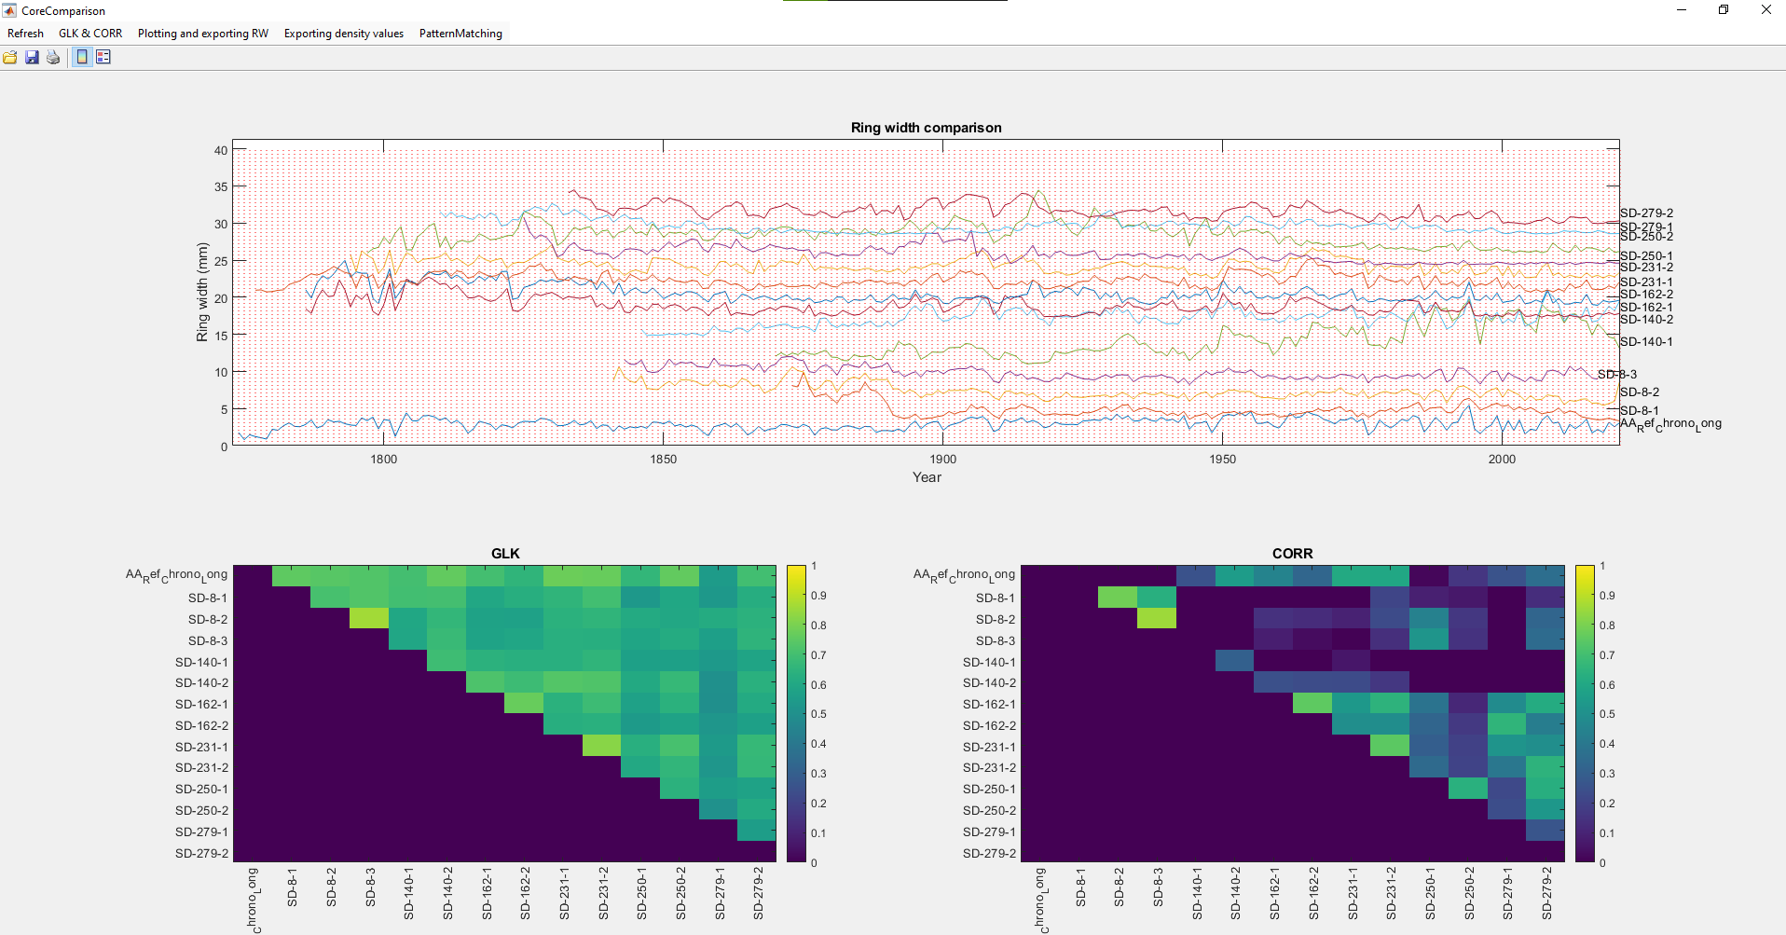

**Running the software**

1. Start the CoreComparison software.
2. Select the .TXT files of the cores you want to compare.
3. You can compare multiple cores at the same time.
4. Open RingIndicator and open the cores you want to edit.
5. Save the edits in RingIndicator, then click refresh in CoreComparisson.

**Using a Reference Chronology**

1. Create a TXT file with the ring width data for the reference chronology using the XCTchron.Rmd, which is also on Git Hub.
2. Copy the reference chronology TXT file to the folder with your cores.
3. Open the Core Comparison software and select the reference chronology along with your cores.

**XCT.Read.R R-function**

**Introduction**

This function was created to easily read and calculate ring width and density parameters using the txt-formatted ring indications and density profile output from by. The section of the profile where a density parameter is calculated can be set by the user: either a fraction of the ring (e.g., the second quarter of each ring) or a fixed width (e.g. the last 100 µm of each ring). The output of the function is a dplR or a long-format data frame.

**How to use**

1. Load the necessary packages, such as tidyverse and dplyr.
2. Load the XCT.Read function into R with source(“XCT.Read.R”).
3. Use the function by defining the following settings:
   1. **path**: A path to the folder containing the txt files.
   2. **output**: The output type, can be "ringwidth" (dplR format of ring width), "density" (dplR format of density parameter), "ringwidth_density" (long format of the sample, year, ring width, and density), or "density_profile" (long format of the sample, year, and density profile in that year)
   3. **densityType**: The type of density to calculate, can be "fraction" or "fixed". "fraction" calculates the density in a variable width window that corresponds to two fraction numbers that go from 0 (start ring) to 1 (end ring), set in variable area. "fixed" calculates the density in a fixed width window, starting from the beginning or the end of the ring. set in variable area.
   4. **area**: Fraction of the ring to calculate the density parameter. If densityType = "fraction" this is a vector of two numbers that go from 0 (start ring) to 1 (end ring). If densityType = "fixed" this is a vector with "start" or "end" as the first variable, and the width of the window in micrometers as the second variable.
   5. **fun**: The function to calculate the density in the selected area, can be "mean", "median", "min", "max", or "mean_top_x". "mean_top_x" calculates the mean of the x highest values in the selected area, the variable x should be set to a fraction between 0 and 1.
   6. **x**: Fraction of the highest values to calculate the mean. Only used if fun = "mean_top_x".
   7. **removeNarrowRings**: Removes density parameters of rings that are too small, set in minRingWidth. Can be either TRUE or FALSE.
   8. **minRingWidth**: Minimum width of the ring in mm that should be used in density calculations, only if removeNarrowRings = TRUE.
   9. **overruleResolution**: Overrule the resolution of the XCT data txts. If TRUE, the resolution of the XCT data is set to the resolution parameter. If FALSE, the resolution is set to the value in the ringwidth.txt file.
   10. **resolution**: The resolution of the data in µm/pixel. Only used if overruleResolution = TRUE.

**Examples**

remove(list = ls())

#### load necessary packages ####

library("tidyverse")

library("dplR")

#### load XCT.Read function ####

source("XCT.Read.R")

# set the path to the folder containing the files

path = "Datafolder"

# ringwidth data

RW <- XCT.read(path, output = "ringwidth")

# mean density of the last 25% of the ring

Density <- XCT.read(path, output = "density", densityType = "fraction", area = c(0.75, 1), fun = "mean")

# mean density of the middle 50% of the ring

Density <- XCT.read(path, output = "density", densityType = "fraction", area = c(0.25, 0.75), fun = "mean")

# mean density of the last 100 micrometers of the ring

Density <- XCT.read(path, output = "density", densityType = "fixed", area = c("end", 100), fun = "mean")

# mean desity of top 20 percent highest density values of the last 300 micrometers of the ring

Density <- XCT.read(path, output = "density", densityType = "fixed", area = c("end", 300), fun = "mean_top_x", x = 0.2)

# mean density of the last 25% of the ring, but only the rings larger than 3 mm

Density <- XCT.read(path, output = "density", densityType = "fraction", area = c(0.75, 1), fun = "mean", removeNarrowRings = TRUE, minRingWidth = 3)

# example use of function long format

Data <- XCT.read(path, output = "ringwidth_density", densityType = "fraction", area = c(0.75, 1), fun = "mean")

# example use density profile long format

Data <- XCT.read(path, output = "density_profile")